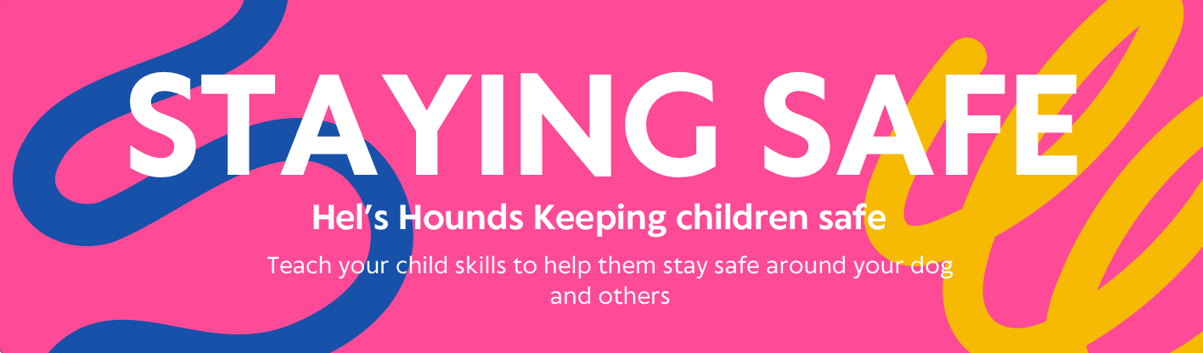

**WHAT TO AVOID?**

* NEVER LET CHILDREN SIT ON OR RIDE ON DOGS, EVEN IF YOU THINK YOUR DOG ENJOYS IT!
* IF YOUR CHILD IS UNDER 10 OR YOUR DOG IS AWAKE: ONE OR BOTH SHOULD BE IN YOUR SIGHT AT ALL TIMES! ATTACH THEM TO YOU IF YOU NEED TOO!
* YES, THIS MEANS THEY SHOULDN’T BE ALLOWED TO SLEEP TOGETHER. AT LEAST UNTIL THEY ARE OLD ENOUGH/ TRAINED ENOUGH/ TRUSTED
* YOUNG OR IRRESPONSIBLE CHILDREN SHOULD NOT BE ALLOWED TO HOLD A DOG'S LEAD.
* Children should not be involved in bathing dog’s until you know your dog’s reaction
* Never allow dogs to get in the bath with your child

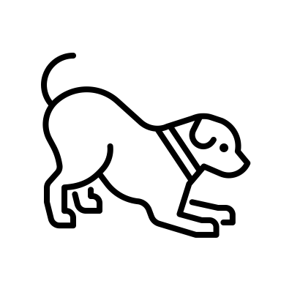**TEACH YOUR CHILD TO AVOID YOUR DOG WHEN:**

* YOUR DOG IS EATING
* YOUR DOG IS PLAYING WITH A NEW OR TREASURED TOY
* YOUR DOG IS SLEEPING
* YOUR DOG IS SICK
* YOUR DOG IS INJURED
* YOUR DOG IS IN PAIN
* YOUR DOG IS IN THEIR “SAFE PLACE”
* YOUR CHILD HAS FOOD
* Without checking with you first - this will give you a chance to assess the situation

**THE TREE TECHNIQUE:**

THIS TECHNIQUE IS USED WHEN A DOG JUMPS AT YOUR CHILD, THIS VERSION IS FOR WHEN THEY ARE ABLE TO REAMIN STANDING.

WHEN A DOG APPROACHES AND JUMPS, YOUR CHILD SHOULD DROP EVERYTHING THEY HAVE IN THEIR HANDS (AFTER ALL, STUFF CAN BE REPLACED), CROSS THEIR ARMS OVER THEIR CHEST.

IT IS ESSENTIAL THAT THEY DO NOT TRY TO RUN, SCREAM OR SHOUT AS THIS COULD SCARE OR STARTLE THE DOG.

EQUALLY, IF IT IS AN UNKNOWN DOG, KEEPING THEIR HANDS OFF THE DOG IS IMPORTANT, YOU DO NOT KNOW WHAT THE DOG WILL TOLERATE. EVEN IF IT IS A FAMILIAR DOG WHICH IS ACTING OUT OR SCARING THEM, TEACH THEM NOT TO TOUCH.

TRY NOT TO LOOK THE DOG IN THE EYE AS THIS CAN BE SEEN AS A THREAT BY SOME DOGS.

AS SOON AS THE DOG HAS GONE A SAFE DISTANCE AWAY, YOUR CHILD SHOULD FIND AN ADULT WHO CAN DEAL WITH THE SITUATION.

**THE ROCK TECHNIQUE:**

THIS IS A TECHNIQUE THAT AIMS TO KEEP YOUR CHILD SAFE SHOULD THEY BE KNOCKED OFF THEIR FEET BY A DOG.

THEY SHOULD LET GO OF ANYTHING THEY WERE HOLDING.

IF THEY CAN GET THEIR KNEES UNDER THEIR BODY, THEY SHOULD DO SO, TUCKING THEMSELVES IN AS TIGHT A BALL AS POSSIBLE, THEIR ARMS AROUND THEIR BODY AND HEAD TUCKED IN.

IF THEY ARE FORCED TO STAY ON THEIR SIDES, THEY SHOULD CURL INTO THE FEOTAL POSITION, THEIR KNEES PULLED UP TO THEIR CHEST, ARMS AROUND THEIR KNEES AND HEAD TUCKED IN.

THIS POSITION AIMS TO PROTECT THEIR TORSO, AND THEREFORE THEIR ORGANS FROM DAMAGE OF A DOG ATTACK IN THE WORSE CASE SCENARIO.

AGAIN, CHILDREN SHOULD NOT RUN, SCREAM OR SHOUT AND SHOULD NOT TRY TO TOUCH OR CALM THE DOG, EVEN IF IT A FAMILIAR DOG.

THEY SHOULD FIND A RESPONSIBLE, FAMILIAR ADULT OR SOMEONE IN UNIFORM WHEN IT IS SAFE TO DO SO.

**SAFE SPACES:**

EVEN THE BEST OF HUMAN AND CANINE FRIENDS NEED SOMEWHERE TO GO FOR A MOMENTS PIECE.

YOUR DOG SHOULD HAVE A SPOT THAT IS SAFE FROM “INVASION” BY YOUR CHILD. THIS COULD BE THEIR BED OR CRATE.

EQUALLY, YOUR CHILD SHOULD HAVE TIMES AWAY FROM YOUR DOG AND SPACE TO GO THAT YOUR DOG CANNOT GO.

always ASSESS EVERY SITUATION AND INTERACTION BETWEEN YOUR DOG AND CHILD.

KEEP A RECORD OF ANY NEGATIVE INTERACTIONS, THIS IS ANYTHING THAT ENDS IN YOUR DOG GETTING OVER EXCITED, YOUR CHILD GETTING HURT (NIPPED, PUSHED OVER, ETC), WHEN YOUR DOG BEHAVES IN A WAY THAT YOU WISH TO CHANGE AROUND OR BECAUSE OF YOUR CHILD, and ANY TIME YOU HAVE TO SEPARATE THEM. THIS WILL ALLOW YOU TO SPOT PATTERNS and can help if you need to contact a trainer. Record the situation, who, what, where, and when, record what happened just before the event and how you reacted.

Find two examples below.

|  |  |  |
| --- | --- | --- |
| **What?**  What happened? | My dog jumped up at my child and knocked them over, he then proceeded to lick my child despite the fact they were crying. | **My dog growled and nearly bit my child. He didn’t break the skin but had my child’s hand in his mouth.** |
| **Where**  Where did it happen? | In the doorway to the lounge. | **My dog was in his bed and my child was sat by him** |
| **When**  When did it happen? | It happened when we came in from school. My child was still wearing their coat. | **It happened when we were all in the lounge in the evening.** |
| **Who**  Who was involved? | My child, and my dog. I was present. | **My dog and my child were involved however myself and my husband were in the room.** |
| **How**  How did you react? | I shouted at my dog and grabbed their collar to pull them off my child. | **I shouted loudly, my child began to cry louder, and my dog barked again, my husband pulled my child away and I shut the dog in his crate.** |
| **Before**  What happened before? | We had just come in. My dog had been alone for a few hours while I had been out running errands before the school run. | **My dog had been sleeping in his bed when my child leant over from her colouring to pet him.** |

In the first example we have an over excited dog who would benefit from learning to greet people with all of his paws on the floor. In the second example, the dog was startled, and while he should not have give a warning bite in an ideal world, can we blame him? The little one would benefit from a lesson in staying safe around their new friend!